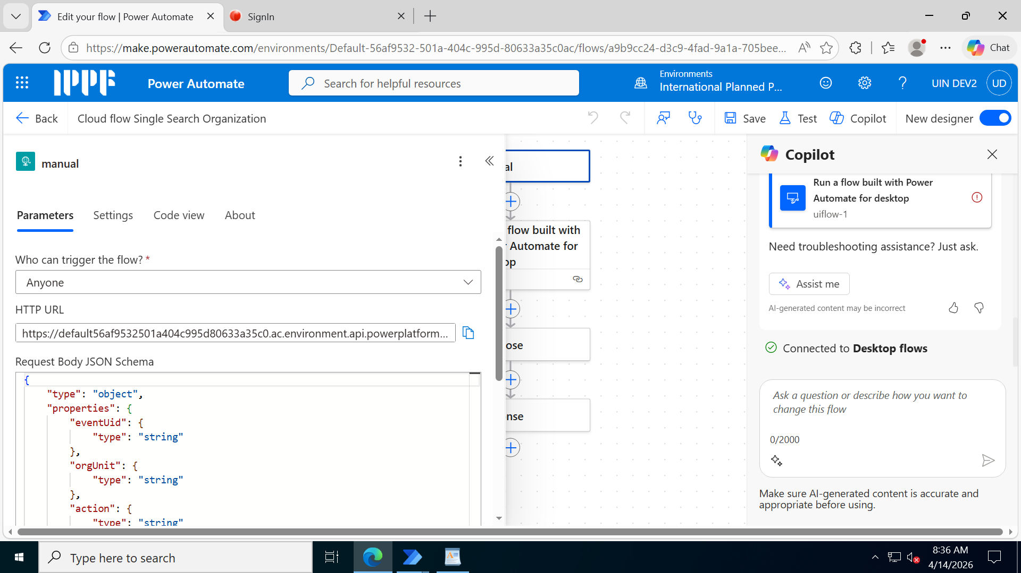
Request Body JSON Schema
{
"type": "object",
"properties": {
"eventUid": {
"type": "string"
},
"orgUnit": {
"type": "string"
},
"action": {
"type": "string"
},
"program": {
"type": "string"
},
"EntityType": {
"type": "string"
},
"OrganizationName": {
"type": "string"
}
}
}

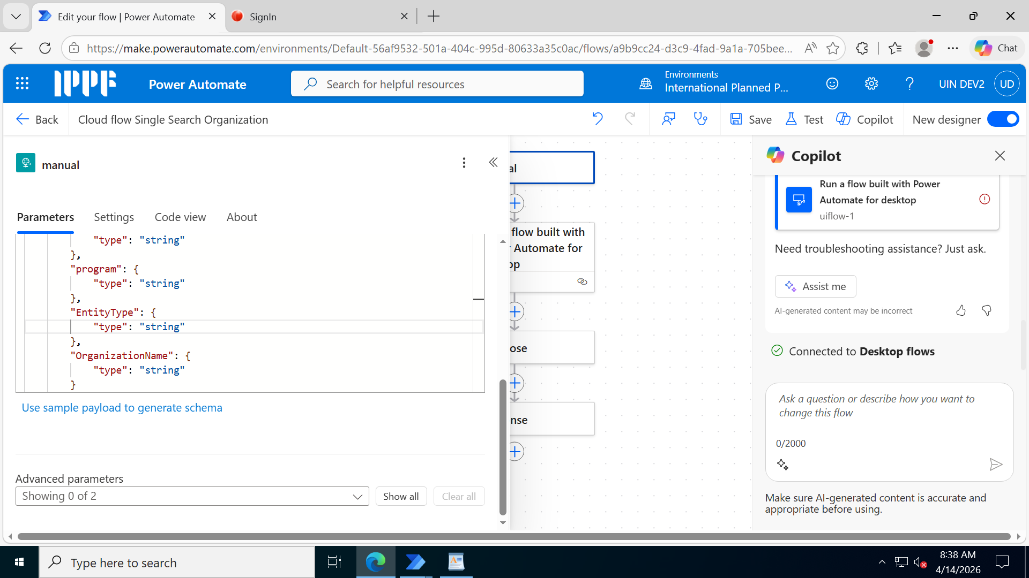

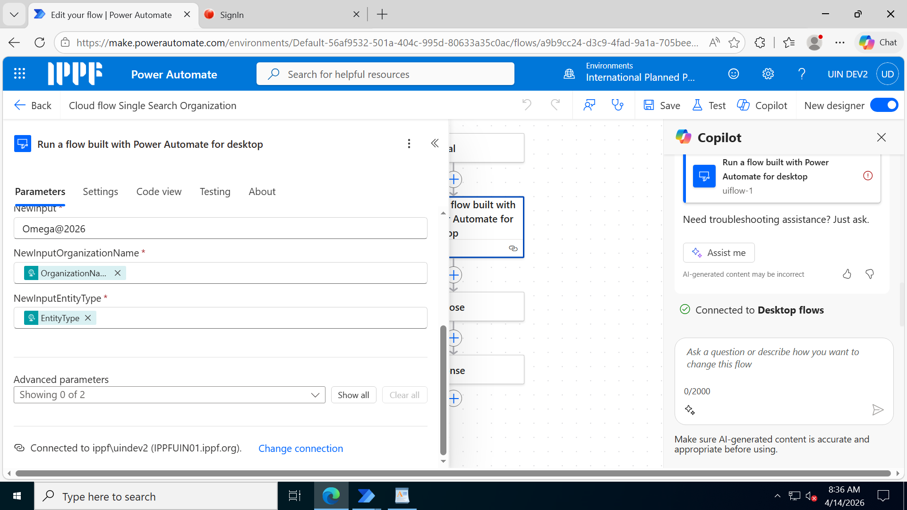

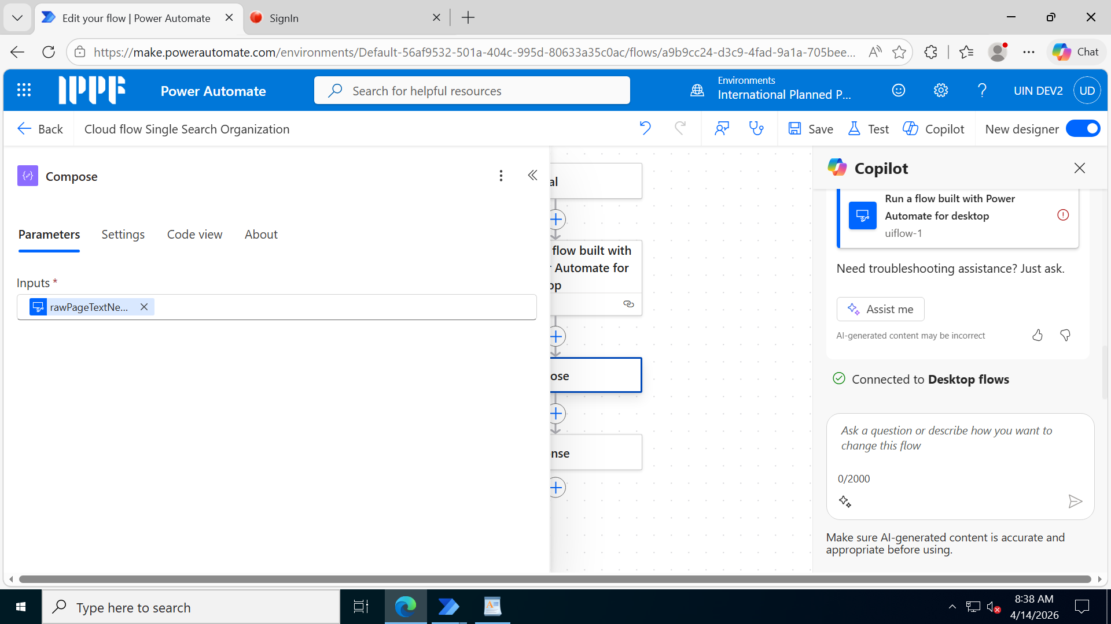

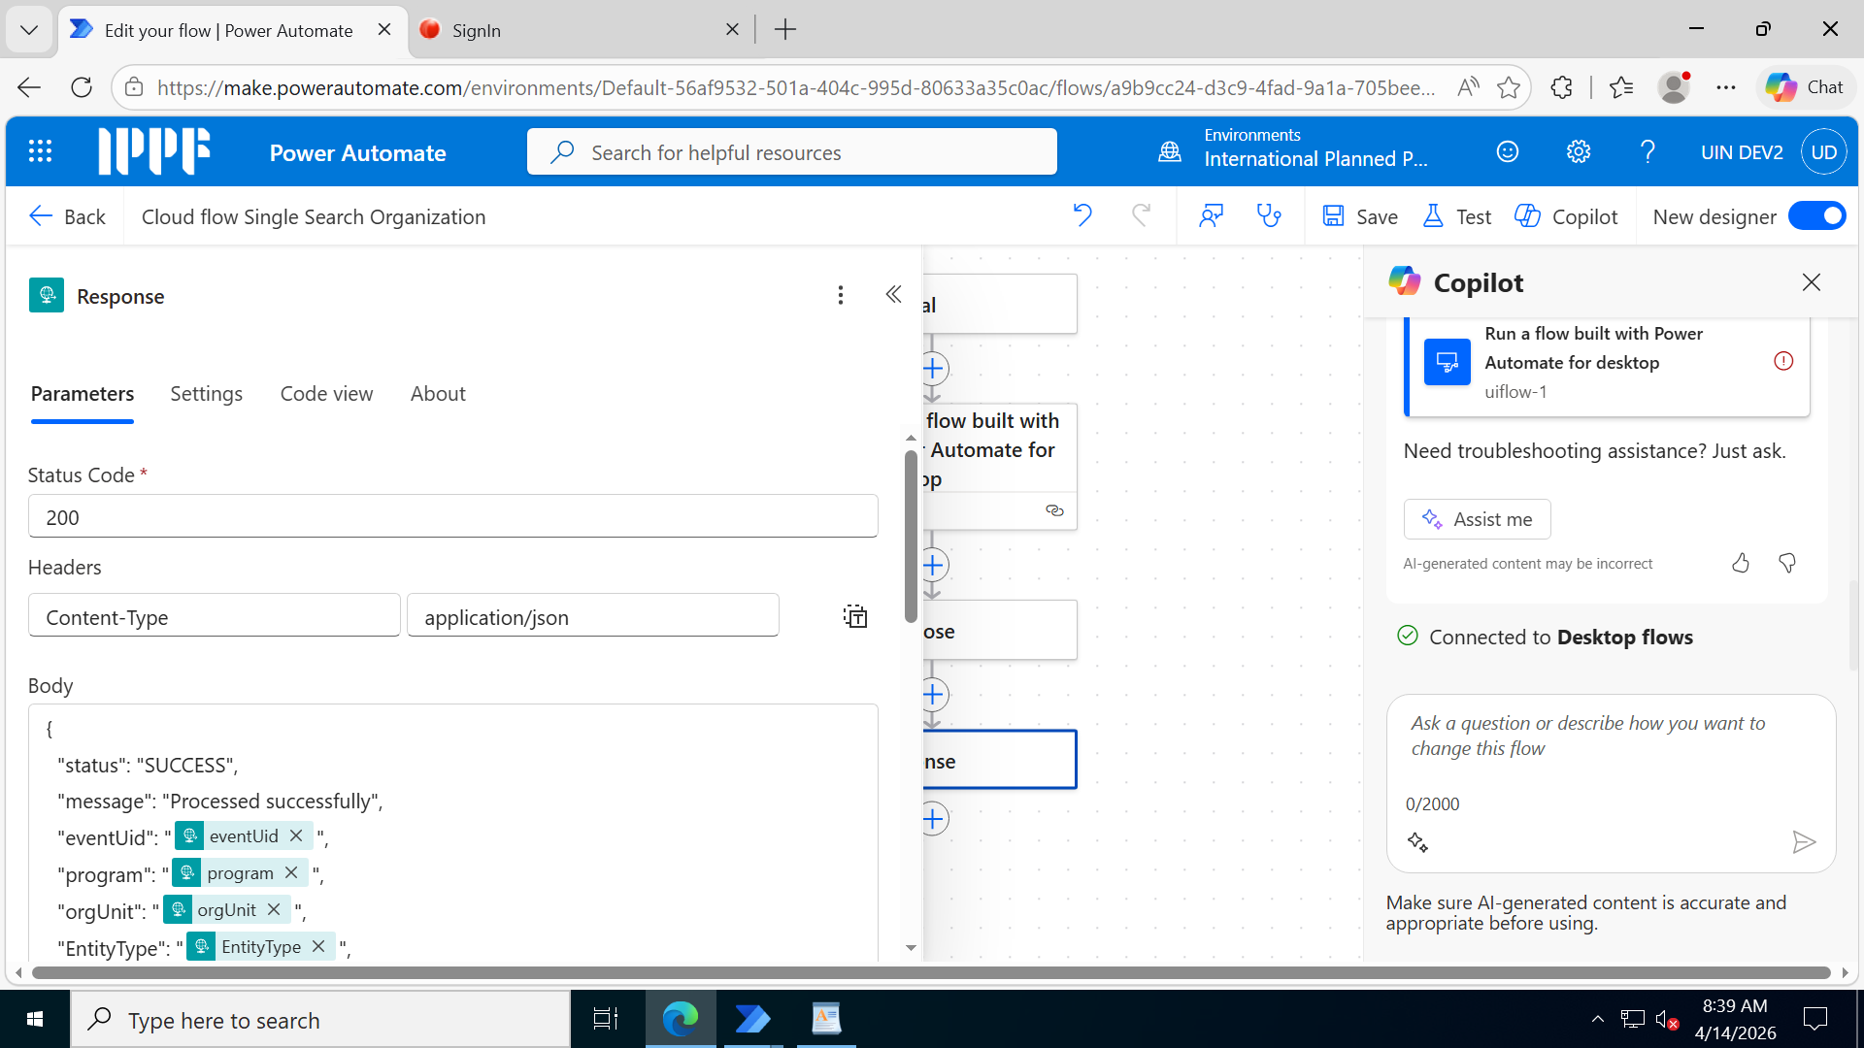

Body
{
"status": "SUCCESS",
"message": "Processed successfully",
"eventUid": "@{triggerBody()?['eventUid']}",
"program": "@{triggerBody()?['program']}",
"orgUnit": "@{triggerBody()?['orgUnit']}",
"EntityType": "@{triggerBody()?['EntityType']}",
"OrganizationName": "@{triggerBody()?['OrganizationName']}",
"rawPageText": "@{outputs('Compose')}"
}

Response Body JSON Schema
{
"type": "object",
"properties": {
"eventUid": {
"type": "string"
},
"orgUnit": {
"type": "string"
},
"action": {
"type": "string"
},
"program": {
"type": "string"
},
"EntityType": {
"type": "string"
},
"OrganizationName": {
"type": "string"
},
"rawPageText": {
"type": "string"
}
}
}

